
Application to trade at
Croydon Harvest – featuring The Walnut Fair
3 and 4 October 2026 12pm – 5pm

The market at Croydon Harvest is curated. There is space for 16 stalls on Katherine Street and 8 gazebos/ trucks in Surrey Street. Additionally, there will be spaces left for regular Surrey Street traders.
Power is available on Surrey Street but not on Katharine Street.
If you are selected, you will be signposted to the relevant trading licence to complete your application. Please do not apply for a licence without being given the go-ahead from Culture Croydon or your application will be rejected. Regular Surrey Street traders should book as normal through Fiona Woodcock.
Please return the form by 11:59pm on Sunday 13 September. Applicants will be told if they have secured a pitch by 5pm Monday 14 September. Send to: croydonharvest@gmail.com
You are advised to read the Terms and Conditions and FAQs before completing this form.
A. YOUR DETAILS | Please note that this application is for the named business/trader. If you would like to share a pitch with another business or an individual please also include their details at the time of application.
Contact name
Trading name
Address including postcode
What day/s would you like to trade?
Please describe your stall/what you sell in no more than 60 words. Note this description will be used to help publicise your inclusion in the event.
Are your goods hand-made/manufactured by you? Please describe your process in no more than 60 words.
Why would your goods suit our Croydon Harvest event?
Where do you usually sell? (Please name a few markets / fairs, websites online platforms etc.)
Are you a regular trader on Surrey Street?
Email address
Contact number
Mobile on the day (if different)
Social media handles / website
Please give the name of your Public Liability Insurance (PLI) provider and expiry date of your cover. | INSURER NAME:  EXPIRY DATE:  INSURANCE LIMIT:  (min £5million)
B. UNLOADING REQUIREMENTS | THIS INFORMATION IS ESSENTIAL TO ENSURE THAT UNLOADING RUNS AS SMOOTHLY AS POSSIBLE. ONLY ONE VEHICLE PER STALL PLEASE.
How will you be travelling to Croydon Harvest? | Car / van  Taxi / Public transport
Your vehicle’s registration, make and colour. If you’re bringing a van or trailer, please state and include size for any large vehicles.

C. STALL REQUIREMENTS
On Katherine Street we will provide a series of marquees for traders to share. You will have an area roughly 3m x 3m.

On Surrey Street you will be expected to bring your own gazebo/van.
Would you like to trade on Katharine Street or on Surrey Street
Do you need electricity? If so, what for?
(NOTE: power points are limited to Surrey Street only and the electric supply there is limited to 2,000 KW).
No generators allowed.
Would you like to bring clothes rails or other display furniture? If yes, please give approx. size.
Space on Surrey Street will be limited at 3x3m. Please let us know the size of your van or gazebo.
We will have a limited number of tables/seats for our customers to sit and eat.
NOTE: All gazebos must be secured fully by appropriate weights (Croydon is windy due to all the tall buildings). This will be inspected by event managers. Gazebos/trucks will be on Surrey Street.
Let us know if you have any other requests/requirements.
I confirm:
I have read the terms and conditions
I have read and understood Croydon Council Trading Licence Conditions
I have included at least two photographs of stock or links to social media?
Have you included details of PLI cover? Do not send certificate at this stage.
Please sign and return the form to before 11.59pm Sunday 13 September.
Please note: If you have missed the above deadline please feel free to email croydonharvest@gmail.com to see if there are any cancellations or available spaces.

Signature: Date:

Terms & conditions
Stallholders
- Each stall is for the named Trader or Business who has booked it. Please do not sub-let or share your stall with someone else unless you have agreed this with us in advance.
- It is a condition of contract that you have read and comply with Croydon Street Trading Licence conditions
- Please do not drink alcohol or smoke in your stall.
- Good hygiene is encouraged, please wash/sanitise your hands after dealing with cash/doing any mucky jobs.
- Please treat all customers, staff and other traders with respect.

Sale of goods
- Any homemade/craft/art/beauty items, or any repurposed or ‘upcycled’ items must be hand-made by you and not imported or mass-produced.
- All stall holders should know the origin of all the products for sale and should be able and willing to communicate this on the website and to the buyers directly.
- Goods, and their constituent parts, must not be illegal for sale.
- Alcohol cannot be sold to minors. Alcohol samples cannot be given to minors.
- Traders selling alcohol to be consumed need to have a TEN.
- No tobacco or vaping products will be permitted. No Cannabis products nor medicinal mushrooms will be permitted.
- Goods cannot be carried on the stall that include swear words or sexual innuendo.
- Goods should be priced at retail (not trade) prices. We recommend a good guideline cap for prices is a maximum £45. Each stall should have at least a few reasonably priced affordable items.
- All goods should be priced inclusive of VAT
- Counterfeit goods must not be sold.
- All traders shall comply with all health and safety legislation and where food is sold they shall also comply with all food hygiene legislation.
- All Licensed Street Traders who sell Food Stuffs must ensure they are registered as a food premises with the Council.
Unloading & Set-up
- Information concerning arrival and set-up will be sent by email approximately one week before the event.
- Please do not bring more than one vehicle to the event, unless you have agreed this with us in advance.
- There will be limited support on the day to help with loading/unloading. Please let us know in advance if you have any access requirements or will need any other additional support.
- You can drive on to Surrey Street from 8am and need to be off by 10am. Katharine Street you can arrive between 9am and be off by 11am. You can collect goods after 5pm on Surrey Street and 5.15pm on Katharine Street. Cars will not be allowed on site at any other times.
- Always be mindful and respectful when parking/stopping/unloading/loading of other traders and do not block the passageway of others.
- If your pitch/stall is on a pedestrianised area you must drive with your hazard lights on at all times.
- Your vehicle must be moved away as soon as your goods are unloaded. There is no organised parking for traders.
- If you are bringing a gazebo you must bring appropriate weights (min 30kg). Failure to provide your own weights on the day may result in cancellation of your pitch.
- Do not extend beyond the extent of your space. Fire routes and visitor circulation areas must be left clear. Traders may be asked to move items if deemed by organisers to be causing a blockage or otherwise hindering visitor movement.
- Rails and additional tables are not available and are not allowed unless arranged in advance.
- Traders cannot take up more space than allocated.
- Do not use nearby shop fronts or other buildings to display your goods.
- Stallholders are responsible for their own rubbish and should take it home with them. Bin bags can be provided.
- Food waste must be disposed of in line with the Trading Licence conditions (link above).

Pitch fee payment
- Please do not make payment until you have received agreement from Culture Croydon/Fiona Woodcock.
- Your pitch may be offered to someone else on the waiting list if payment is not made by the required date on your invoice.

Pitch fee
- Fee will be confirmed upon allocation of space and application for the trading licence. By way of a guide:
    - Katharine Street £15 per day.
    - Surrey Street Saturday: new traders £10, existing Traders £20.
    - All traders Surrey Street Sunday: £20.
    - Free for relevant information stalls.
- Alcohol traders selling for consumption also need to organise and pay for a TEN.
- No refunds for cancellations.
- If the event is cancelled by the organiser for any reason, the trading licence fee will be returned to you.

PAYMENT WILL BE TAKEN AS ACCEPTANCE OF THESE TERMS & CONDITIONS.

Frequently asked questions

If I sell jams, teas or cake does that count as a food truck/trader?
Any trader selling packaged store cupboard food products or cakes/bread etc. must ensure they are registered as a food premises. The sale of such goods does not however mean you need to apply as a food truck

By food truck/trader we are referring to those selling lunch, breakfast goods or drinks, such as a jerk chicken truck, a coffee and cake tuk tuk, a souvlaki stall etc..

Do I need insurance?
All traders must have at least £5million in public liability insurance (current and dated for the event).

Can I park by my pitch?
You can drive your vehicle UP TO your pre allocated pitch for unloading and loading back up. Drive on to Surrey Street from 8am and you must be off by 10am. High Street/Katharine Street you can arrive between 9am and be off by 11am. You can collect goods after 5pm on Surrey Street and 5.15pm on High Street/Katharine Street. Cars will not be allowed on site at any other times.

Please take extreme care when driving your vehicle on-site – there are ALWAYS pedestrians about.

A road closure will be in place between 10am and 6pm on Katharine Street, traders will have access to collect their goods after 5.15pm.

You will be issued with a permit to drive down Surrey Street. Arrival times for Surrey Street may vary depending on the number of bookings.

Are stalls, gazebos and work surface provided?
You may book for a circa 3x3m pitch on Katharine Street within a shared marquee which will have 2 X trestle tables and chairs and a roof cover. Please note, you will have a neighbouring stall on one or both sides. There will be enough room to allow traders to get to the front easily.

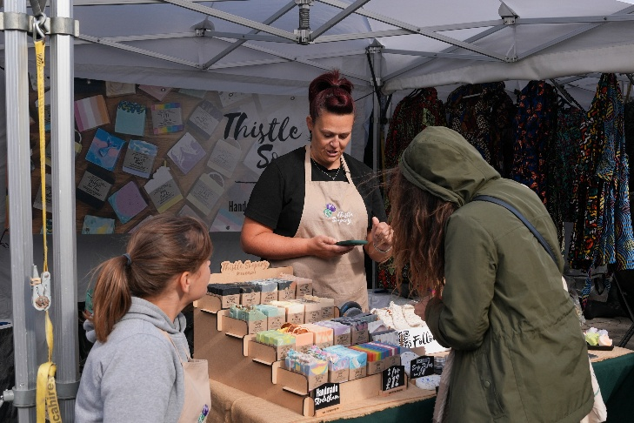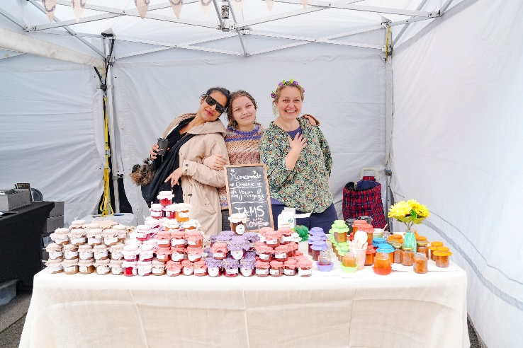
Croydon Harvest Market in Katharine Street 2025

We cannot provide gazebos for Surrey Street. If you are bringing your own, your pitch size is 3m x 3m. The gazebo must be of commercial quality with weights. Please ask if you need confirmation of what is classed as ‘commercial’. If you are bringing your gazebo you must bring sufficient weights (Croydon is windy). You must also bring your own tables/counters and chairs.

Can I bring my own table?
Surrey Street Traders bringing a gazebo need to bring their own tables/chairs/stall dressings.

Two tables will be provided for traders in Katharine Street, if you would rather bring your own, please let us know in Section C above.

Traders bringing trucks may bring one small table to place alongside the truck.

Other traders cannot bring additional rails/tables etc. without prior approval.

Are there toilets?
Toilets will be available in Croydon Clocktower, Katharine Street.

Security may be able to watch your stall whilst you go to the bathroom but this is not guaranteed. Please buddy up with other traders to provide cover.

Can I leave goods/my truck overnight?
Not on Surrey Street

There will be overnight security on Katharine Street but goods are left at your own risk. Security will be there to guard the stage and technical equipment, the market will not be their priority.

What time can I arrive?
Surrey Street from 8am and need to be off by 10am.
Katharine Street you can arrive between 9am and be off by 11am.
You can collect goods after 5pm on Surrey Street and 5.15pm on Katharine Street. Cars will not be allowed on site at any other times.

Can I choose my pitch?
Your pitch will be allocated to you via email on the Tuesday or Wednesday before the market.

If I cancel my booked pitch, can I get my money back?
If you cancel, you will not be offered a refund.

If the event is cancelled for any reason, such as adverse weather, your fee will be refunded.

