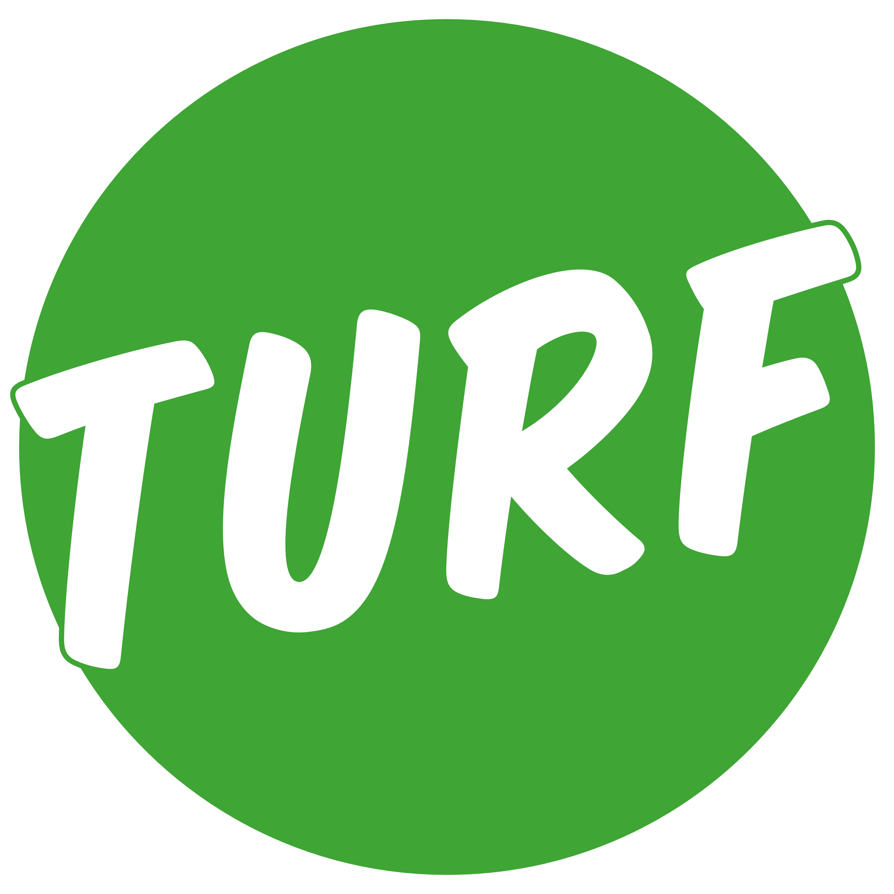
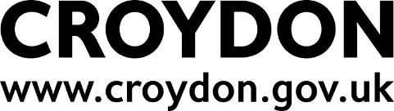

ART ON OUR DOORSTEP
CROYDON’S CONTEMPORARY ART FAIR
12 – 14 June 2026
CALL FOR ARTISTS

Thank you for your interest in applying for Art On Our Doorstep. Croydon’s Contemporary Art Fair is open to any professional artist from Croydon or currently living and practising in Croydon.

The event will be able to accommodate up to 30 professional artists. By professional artists we mean people who earn all or a portion of their income through their art practice (for example through exhibition, sale, commission, participatory/socially engaged events or teaching). They should have a demonstrable commitment to their craft rather than it being a hobby. New or recent graduates of art schools or University honours art courses may also apply.

Closing date for applications is 23:59 BST, Sunday 19 April 2026.

Please read the information in this document and the terms of entry before making an application.

NEED TO KNOW
- Copyright:
Intellectual Rights: Artists that enter their work confirm that they hold all intellectual property rights.
Artwork rights: You will retain the copyright to all work submitted however if you are included in the exhibition, your work will be captured in photographs and film by Croydon Council and its funders to support event marketing and evaluation. The general public must also be allowed to freely capture the work (on a not-for-profit basis).

- Submission Details
Submissions should be proposals for two-dimensional works in any media and for small and/or medium three-dimensional work. This includes but is not limited to: ceramics, collage, digitally created work, drawing, mixed media, painting, photography, prints, small sculpture, textiles, text work. We will not be able to show film or work on screens.
It is unlikely that we will be able to host performance work but we are open to discussion on this.
Please include the following details of your artworks when submitted.
- Number of artworks.
- Artwork dimension, in millimetres, for each individual artwork,
- Artwork weight, in kilograms, for each individual artwork,
- Artwork medium and material, including any framing. Fixing method for artwork

Proposals should include a selection of up to four (4) visual references. These may be previous works, drawings, photographs, sketches, models, mood boards and renders – anything that helps us understand and visualise your practice. Artworks can be submitted in portrait or landscape dimensions. See application form for details on how to submit.

Applications must be submitted by the artist or by the gallery representing them.

You can only submit one application, and we will consider your first application only. You cannot change your application form once it has been submitted.

Closing date for applications is 23:59 BST, Sunday 19 April 2026.

- Size/available space
Art works are expected to be transported and carried by the artists into the event. Generally, two-dimensional artworks over 1500mm x 2000mm and over 3kg will not be accepted. (There are a limited number of spaces to present works up to 10kg in weight)

Small and medium sized sculptures should be under 25kg and should be able to fit on a standard trestle table. Sculptures over 500mm x 500mm x 500mm will not generally be accepted.

Two-dimensional artworks will be able to be mounted on either a lightweight metal grid, using hooks, cable ties or similar, as appropriate for the artwork. Or a limited number of temporary timber walls are available, which can be screwed into.

You can propose new or existing artworks (no more than five years old) for your area. The following sized spaces are available
For two-dimensional artworks
- 1200mm wide x 1800mm high
- 3500mm wide x 1800mm high

For three-dimensional artworks
- 1800mm long x 700mm deep

Artists can request up to three (3) display areas of the same size. Not all requests for multiple spaces will be granted.
Glass framed works will not be accepted.

- Transportation/installation/de-rig
Artists will be responsible for delivery, installation, display, deinstallation and removal of their artworks. A small number of technicians (and tools) will be on site to support, but artists should be self-sufficient.
Drop-off with either via North End between 6pm – 10am or during the day via the Whitgift Car Park.

- On-the-day
Artists and/or their representative will be expected to be on site throughout the weekend to manage their artwork and any related enquiries.

Artists may (but do not have to) sell their work at the event. This is to be organised directly between the Artist and the Purchaser. You will be allowed to use card readers or manage a paper or online payment system. There is no Wi-Fi network available for sellers, card reader machines must be used with Artists’ own mobile phone.

Croydon Council and the Whitgift Centre will not take any responsibility for any part of the buying/selling process including any lost or damaged works, or any fraudulent transactions

Artists are advised not to bring work of extremely high value into the Whitgift Centre.

Artist should have their own insurance for their artwork and their own public liability insurance of at least £1million. Insurance is available through membership of organisations such as the Artist Union or the Artists Network.

Event security will be on site throughout to support, but they cannot take responsibility for Artists’ artwork.

- Stipend
Professional artists will be given a stipend of £500 to support their participation in the event. Stipends will be paid from the week of 15 June 2026 following full participation in the event and upon receipt of a completed evaluation form.
Artists must be registered as self-employed (with a UTR number) or as a limited company to be entitled to this stipend. If you are applying as a collective, the collective will count as one artist and therefore be entitled to one stipend.

We look forward to receiving your application.

APPLICATION FORM
All questions are mandatory
If you need any help with completing your application please contact culture@croydon.gov.uk.

I confirm that I hold all intellectual property rights for the work that I am submitting, and that I will declare any use of Artificial Intelligence:
Accept ☐ Don’t Accept ☐

Please tick which sentence best describes you:
I was brought up in Croydon and still live and practice here ☐
I was brought up in Croydon but now live and practice somewhere else ☐
I was brought up somewhere else but now live and practice in Croydon ☐

First and Last name of Artist:

Name of gallery/agent if submitting on behalf of the Artist:

Email address:

Mobile number:

Full home or studio address including postcode:

Current country of residence:

For those no longer living/working in Croydon please include the street name and postcode of where you grew up:

For those living elsewhere but working in Croydon please include the name and postcode of your studio or place of work (if different from above):

Artist bio:
Please provide a short professional biography which can include career highlights, education and a summary of your work. The limit is 200 words. Include Website (if applicable): Social media handles (if applicable): this includes Instagram, Facebook, and YouTube. Note, if selected, an edited version of this bio will appear in the event programme.

What genre best describes your work:
For example: Photography. The limit is 10 words.

Describe your existing or proposed artwork:
The limit is 200 words. Note, if selected, this information will be edited and appear in the event programme.

Space/display requirements

Please include dimensions and weights of your artworks,

Approximate price range of work if selling:
You are advised not to bring work of extremely high value to the Whitgift Centre.
List Lowest to highest range, i.e. £250 - £1,500

Please tick:
I have or will take out public liability insurance of at least £1million before taking part in this art fair. ☐

Signature

Please share up to four (4) supporting images. Images must be uploaded as JPG, PNG, TIFF or SVG files. We are not looking at present for any moving-image work, which means we cannot accept animation files such as .GIF
Files must be no larger than 2MB. Make sure you upload high-quality images, as poor or low-resolution (less than 72 dpi) images may affect your chance of being selected.
Please name any supporting images in this format: “Artist Name _Image Title/ Description_ File Number”
Please ensure you have set access permissions to ‘open’ if you are using a cloud platform.

Share this form and your images with us by email: culture@croydon.gov.uk – Put AOOD and your surname then first name in the subject line i.e. AOOD Monet Claude

